Miguel Hilario

CS-255

Module 5

**Business Requirements**

**System Components and Design**

**Purpose:** The system aims to offer thorough driver training services to customers, covering online classes, practice tests, on-the-road training, and appointment scheduling. It seeks to address the demand for improved driver training and preparation for DMV tests.

**System Background:** DriverPass, a new company established by Liam, seeks to fill a gap in the market for effective driver training. The system will act as a platform for customers to access training materials, schedule appointments, and engage with company services, promoting smooth communication and data management.

**Objectives and Goals:**

* Provide easy online access to driver training materials.
* Simplify appointment scheduling for customers and company staff.
* Ensure compliance with DMV regulations and keep training materials up-to-date.
* Enhance customer satisfaction through user-friendly interfaces and efficient service delivery.

**Requirements:**

**Nonfunctional Requirements:**

Performance Requirements:

* The system should handle multiple users simultaneously with minimal delays.
* User interactions, such as scheduling appointments, should have fast response times.
* The system should scale smoothly to accommodate increased user activity and data volume.

Platform Constraints:

* The system should be accessible via the web on various devices, including computers and mobile devices.
* Cloud hosting is preferred for reliability, scalability, and reduced maintenance overhead.

Accuracy and Precision:

* Data accuracy is crucial, especially for customer information, appointments, and training records.
* The system should accurately track user progress, reservations, and training activities.

Adaptability:

* The system should be flexible to accommodate changes in training packages, DMV regulations, and customer needs.
* It should support seamless integration of new features and updates without disrupting existing functionality.

Security:

* User data, including personal and payment details, must be securely stored and encrypted.
* Role-based access control should limit system privileges based on user roles.
* Measures should be in place to detect and address potential security threats, such as data breaches.

**Functional Requirements:**

User Interface:

* The user interface should be intuitive, allowing easy navigation and access to features.
* Key features like progress tracking and appointment scheduling should be prominently displayed.
* The interface design should align with the company's branding and provide a consistent experience across devices.

Assumptions:

* Customers are assumed to have basic internet access and familiarity with online platforms.
* The system assumes compliance with relevant data protection regulations.

Limitations:

* System effectiveness may be impacted by factors like internet connectivity and device compatibility.
* Occasional downtime or technical issues may occur despite efforts to ensure system reliability.

**Schedule:**

Please refer to the attached Gantt chart for the project schedule, outlining tasks, durations, and dependencies based on provided information.

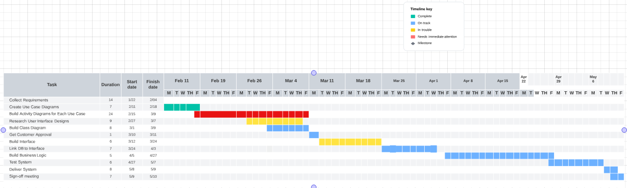

This document outlines the business requirements for the DriverPass system, providing a roadmap for its design and development to meet client needs and expectations.